Disclaimer: I DO NOT claim or guarantee whether the answer written here is 100% accurate. If you feel something is not accurate or out-of-order or want to contribute, it will be a great help, if you let me know. Question which are crossed refers to the repeated question which has been answered already but this rule hasn’t been applied to all repeated question. Use Chrome to read this PDF properly. All question are from Pokhara University board exam papers of BCA.
Author : Pranav Bhattarai
2021 Fall
Tips:
The columns are known as attributes whereas the rows are known as records.
1 a) List out application of DBMS? Explain about physical and logical data independence.
1 b) Define data model? Explain Entry-relationship model with an example.

2 a) Consider the relational database:
employee (person-name, street, city)
works (person-name, bank-name, salary)
bank (bank-name, city)
manages (person-name, manager-name)
Write relational algebraic expression for following tasks:
i) Find the names of all employee in database who live in same city as the company for which they work.
ii) List average salary of employee company wise.
iii) Modify the database so that Gopal now lives in Dharan.
iv) Delete the tuples in works relation for employee of Global Bank.

2 b) Define DDL and DML. Consider the following relations and perform the following operations:
Workers_info(worker_id, worker_name, hrly_rate, supv_id, skill_type)
Assignment_details(asg_id, worker_id, start_data, bldg_id, num_days)
Building_info(bldg_id, bldg_name, bldg_location)
Write the sql statements for following queries.
i) Create table Building_info.
ii) Delete all the workers that are not assigned to any building.
iii) Give the average hrly_rate of workers who are assigned to building 888.

3 a) What do you mean by join? Explain different types of join.
3 b) Define database constraints. Explain integrity constraints and referential constraints with examples.
4 a) Explain functional dependency with its types? For R={A, B, C, D} and F={A→BC, AB→C, AC→D}, List closure of functional dependency F.
4 b) Explain in brief about security issue in DBMS. Explain steps in query processing and optimization with suitable diagram.
5 a) Construct a B+ tree for the following set of key values: {2, 5, 7, 9, 11, 17, 21, 23, 29, 31}. Assume that the tree is initially empty and values are added in ascending order where the pointer number is FOUR.
5 b) What is crash recovery system? Explain shadow paging recovery technique.
6 a) What are ACID properties of transactions? Explain Serializability and its types.
6 b) Differentiate between relational model and object oriented relation model. Explain distributed database with their advantages and disadvantages.

7. Write short notes on any two:
a) Stored Procedure
b) Normalization
c) Encryption and Decryption

2019 Fall

1 a) What is data independence? Explain the Type of data independence.
Data independence means that upper levels are unaffected by changes to lower levels.
Data Independence is defined as a property of DBMS that helps us to change the Database schema at one level of a database system without requiring to change the schema at the next higher level.

There are two types of data independence:

i) Physical data independence can be defined as the immunity of the conceptual schema to changes in the internal schema.

Physical data independence is the ability to modify the physical schema without causing application programs to be rewritten. Modifications at the physical level are occasionally necessary to improve performance. It means we change the physical storage/level without affecting the conceptual or external view of the data. The new changes are absorbed by mapping techniques.

ii) Logical data independence can be defined as the immunity of the external schema to changes in the conceptual schema.

Logical data independence is the ability to modify the logical schema without causing application program to be rewritten. Modifications at the logical level are necessary whenever the logical structure of the database is altered (for example, when money-market accounts are added to banking system). Logical Data independence means if we add some new columns or remove some columns from table then the user view and programs should not change. For example: consider two users A & B. Both are selecting the fields "Employee_Number" and "Employee_Name". If user B adds a new column (e.g. salary) to his table, it will not affect the external view for user A, though the internal schema of the database has been changed for both users A & B.

Logical data independence is more difficult to achieve than physical data independence, since application programs are heavily dependent on the logical structure of the data that they access.
______________________________________________________________________________________________________________________________
1 b) Draw E-R diagram of "Library management system". Assume necessary entity and attributes.
name
pub_ID
address

Ans:
Here,

Student is the entity which has attributes like faculty, name and ID.

Similarly, Teacher, Books and Publisher are also entities.
Name, Address and Faculty are attributes.

→ Rectangle is represented entities.

→ Eclipse is used to represent attribute.
→ Diamond is used to represent relationship.

→ Line is used to link entities, attribute and relationship.
Publisher
teacher_id
name
address

Published by
Teacher

Student
Books
Borrow by

author
available
name
faculty
student_id
title
price

______________________________________________________________________________________________________________________________

2 a) What is schema? Explain the important importance of view in database.

A database schema is the skeleton structure that represents the logical view of the entire database. It defines how the data is organized and how the relations among them are associated. It formulates all the constraints that are to be applied on the data.

Views are the features of SQL databases which are stores logically into the database, we can say that View is a virtual table in the database where contents are defined by the query.

A view is used for security purpose in the database and act as an intermediate between real tables schema & programmability. It also restricts the user from viewing certain columns and row as well. View always represents custom output which is mentioned in the query & returns that data every time which defined in the query at the time of creation.

Views also provide these specific features:

i) Consistency
A view will always represent the same presentation every time even when we perform more normalization to the Tables schema or renamed the tables or restructured the table.

ii) Data Integrity
When a data is viewed or entered by a view in a database. The DBMS will automatically check the data to ensure that this meets the specified integrity constraints.

iii) Security
Views provide the security from unauthorized access to data. Each user can be a given permission to access the database from a view that contains a specified data which a user is authorized to see, thus it restricts the user to see any unauthorized data.

iv. Structural unity
The view provides a custom view of database structure, representing a database like a set of a virtual or custom table which is useful for a user & provides only relevant data to the user.

v. Query Simplicity
A View is constructed from different-different tables & present like a single table. So multiple simple queries combine to make a view so that a view can represent like a table having custom or filter data contained in a virtual table.

vi. Data Independence
Views provides a data independence to an application, because the application will dependent upon a view not on a real table, so any change in the table will not effect an application and an application will always independent from table schema design.

_________________________________________________________________________________________________________________________________________________

2 b) Write the SQL statements that will answer questions I to IV based on the given below table EMPLOYEE.

Emp_ID | Emp_Name | Emp_City | Dept_NO | Salary
E001 | Ramesh | KTM | 101 | 25000
E002 | Radha | NGT | 201 | 20000
E003 | Seema | BRT | 101 | 35000
E004 | Aastha | BRT | 301 | 40000
i. Write a SQL query to list the employees who are getting salary more than 25000 and less than 50000.
ii. Write a SQL query to list the employees who are belong the city of KTM or BRT.
iii. Write a SQL query to display the employee name who is getting highest salary employee.
mysql -u pranav -p//Give password which of Pranav database after this
create database exam;
use exam;
create table EMPLOYEE (Emp_ID int primary key, Emp_Name varchar(15));
alter table EMPLOYEE add column Emp_City varchar(15), add column Dept_NO int(5);
alter table EMPLOYEE add column Salary int(5));
insert into EMPLOYEE values (1, ‘Ramesh’, ‘KTM’, 101, 25000);
insert into EMPLOYEE values (2, ‘Radha’, ‘NGT’, 201, 20000);
insert into EMPLOYEE values (3, ‘Seema’, ‘BRT’, 101, 35000);
insert into EMPLOYEE values (4, ‘Aastha’, ‘BRT’, 301, 40000);
iv. Write a SQL query to display the total salary of each department.

Solution:

i) select Emp_Name from EMPLOYEE where Salary > 25000 and Salary < 50000;
ii) select Emp_Name from EMPLOYEE where location = ‘KTM’ or location = ‘BRT’;
iii) select Emp_Name from EMPLOYEE where Salary = (select max(Salary) from EMPLOYEE);
iv) select Dept_No, sum(Salary) from EMPLOYEE group by Dept_No;

_________________________________________________________________________________________________________________________________________________

3 a) What do you mean by inner join? Describe left outer join with example.

Left Outer Join
A left outer join returns all the values from an inner join plus all values in the left table that do not match to the right table, including rows with NULL (empty) values in the link column.
__________________________________________________________________________________________________________________________________________________
3 b) Define database constraints. Explain unique key constraint and foreign key constraint.

Constraints are the rules enforced on the data columns of a table. These are used to limit the type of data that can go into a table. This ensures the accuracy and reliability of the data in the database.

Constraints could be either on a column level or a table level. The column level constraints are applied only to one column, whereas the table level constraints are applied to the whole table.

Unique key constraints – It ensures that all values in a column are different.
The UNIQUE Constraint prevents two records from having identical values in a column.

For example, in the CUSTOMERS table, for example, we might want to prevent two or more people from having an identical age.

Foreign key constraints – It uniquely identifies a row/record in any of the given database table.

__________________________________________________________________________________________________________________________________________________
4 a) What are the importance of data normalization? Differentiate between 2NF and 3NF.

2NF | 3NF
Transitive functional dependency can be permitted. | Transitive functional dependency cannot be permitted.
Its goal is to eliminate redundant data. | It goal is to ensure data dependencies.
2NF allows non-prime attributes to be functionally dependent on non-prime attributes. | 3NF allows non-prime attributes to be functionally dependent only on super key.
When the table is in 2NF, it is in 1NF. | When a table is in 3NF, it is in 2NF.
__________________________________________________________________________________________________________________________________________________
4 b) What is an encryption? How is an encryption protecting our data? Explain the type of encryption.
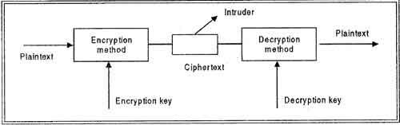
Encryption is a method of encoding data for security purposes. ------------------------------→
AES, RC4, RSA SHA1, etc are some famous encryption methods/algorithms used to encrypt data.

To secure database there are four types of encryption :

i) Business Application Encryption (BAE)
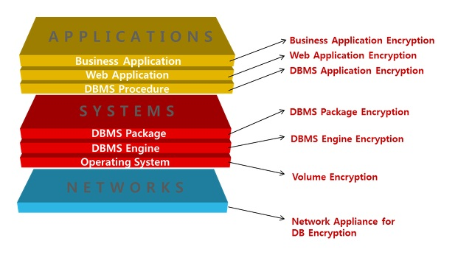
A encryption applies encryption/decryption API on the application or business application server and is applicable to all DBMS without restriction. Although the BA encryption method does not impose additional burden to the DBMS, encryption process can, however, be quite time-consuming because every query related to the encryption data must be modified before the data enter the database.

ii) DBMS Application Encryption (DA)
This type of DB encryption performs encryption/decryption by applying a DBMS product module as a form of API. Similar to the BA encryption method mentioned above, DA is applicable to various DBMS. While query modification is similar, the computational burden of encryption/decryption does not get transferred to the database server because it can be managed from the DBMS administration tool. Moreover, DA addresses security threats that occur in the network section within the network environment. The downside to this encryption method is the need to carry out a certain level of application modificatio

iii) Database Package Encryption (DP)
This encryption method performs encryption/decryption by installing a product module onto the DBMS. Since the module is installed on the DBMS as a form of package, DP encryption method can support indexing of encrypted columns and can be implemented easily without additional query modifications. Also, audit functions through GUI and access control can be provided as an integrated security function. Unlike the API method, this encryption package in DBMS works independently of the application and requires less modification to the query and code making it a flexible option for both commercial DBMS and open source databases.

iv) DBMS Engine Encryption (DE)
Lastly, the engine encryption method or DE is the most evolved form of DB encryption methods. Since encryption/decryption is performed at the engine-level of the DBMS, implementation is the easiest and fast encryption/decryption performance is also faster compared to others. Because this method requires engine-level modification, it can only be provided in a few cases. First, by DBMS vendors. Second, provided through open source DBMS such as MySQL or MariaDB. Third, by collaboration between database encryption companies and database companies. In case of solutions provided by DBMS vendors, such as Oracle’s TDE or SQL Server TDE, only encryption functions will be available without the access control or audit functions. To apply integrated security, a separate package to needs to be purchased and applied. Another term that describes this type of database encryption method is ‘Transparent Data Encryption Method’.

__________________________________________________________________________________________________________________________________________________
5 a) Define the query optimization. Explain the steps for query processing.

Query optimization is the overall process of choosing the most efficient means of executing a SQL statement.
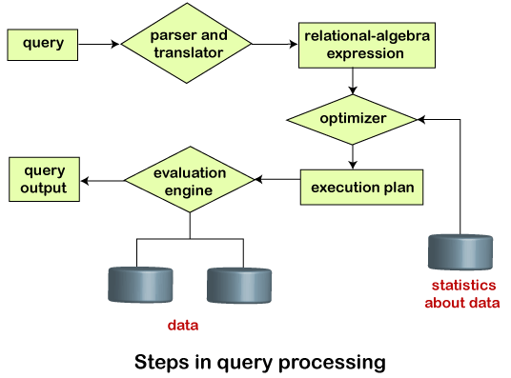
Steps of query optimization:

i) Query tree generation
ii) Query Plan generation
iii) Code generation

Query Processing is the activity performed in extracting data from the database.
In query processing, it takes various steps for fetching the data from the database.

The steps involved are:

i) Parsing & Translation
ii) Optimization
iii) Evaluation
_______________________________________________________________________________________________________________________________________________
5 b) Define an indexing? Explain the B+ Tree index file organization.

Indexing is a data structure technique to efficiently retrieve records from the database files based on some attributes on which the indexing has been done. Indexing in database systems is similar to what we see in books. Indexing is defined based on its indexing attributes.

Indexing can be of the following types −
i) Primary Index
ii) Secondary Index
iii) Clustering Index

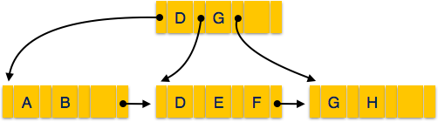
A B+ tree is a balanced binary search tree that follows a multi-level index format.
The leaf nodes of a B+ tree denote actual data pointers. B+ tree ensures that all leaf nodes remain at the same height, thus balanced. Additionally, the leaf nodes are linked using a link list; therefore, a B+ tree can support random access as well as sequential access.

Every leaf node is at equal distance from the root node. A B+ tree is of the order n where n is fixed for every B+ tree.

__________________________________________________________________________________________________________________________________________________
6 a) What is crash recovery system? Explain shadow paging recovery technique.
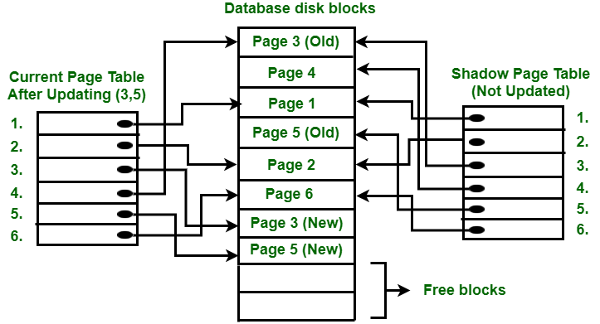

Shadow Paging is recovery technique that is used to recover database.

In this recovery technique, database is considered as made up of fixed size of logical units of storage which are referred as pages.
__________________________________________________________________________________________________________________________________________________
6 b) What is serialization? Explain the serialization view with an example.
__________________________________________________________________________________________________________________________________________________
7. Write short notes on any two:
a) BCNF

__________________________________________________________________________________________________________________________________________________

b) ACID properties of transaction
ACID stands for atomicity , consistency, isolation, durability. It is a set of properties of database transaction intended to guarantee validity even in the event of errors, power failures, etc.
i. Atomicity
Atomicity ensures that each transaction to be “all or nothing”………..

ii. Consistency
This property ensure that any transaction will bring the DB from one valid state to another. Any data written in the database must be valid according to all defined rules, including constrains, cascades, tirggers and any combination thereof. This doesn’t guarantee correctness of the transaction in all the application programming

__________________________________________________________________________________________________________________________________________________
c) Object oriented Model (ORM)
__________________________________________________________________________________________________________________________________________________
2018 Spring

1 a) Discuss the problems in file processing system and explain how DBMS reduces it in your words.

__________________________________________________________________________________________________________________________________________________
1 b) Draw an E-R diagram for the banking system. There are following entities are used, tblEmployees which records the employee related data where Emp_id is an unique identifer, tblBranch which records the bank’s branch information where Branch_id is an unique identifier, tblcustomer which records new customer information and Account_no is an unique identifier, tblAccount which records the transaction information, like as deposit or withdraw, tblLoan which records loan data where loan_no is an unique identifier. You can add other attributes in each entity as per their uses.
__________________________________________________________________________________________________________________________________________________

2 a) What do you mean by keys in database? Explain each of them with example.
__________________________________________________________________________________________________________________________________________________
How to insert/update a value inside a column of one row?
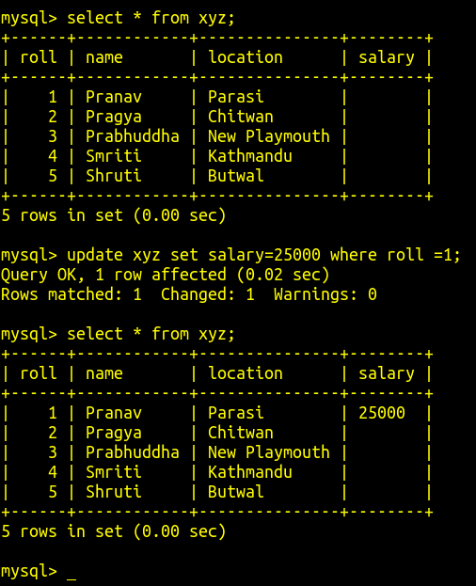
2 b) Consider following relations:
employee (emp_name, street, city)
works (emp_name, city)
manages (emp_name, manager_name)

Write SQL statements for:
i) Find employee names that lives in the city same as the company city.
ii) List all employee details who earn more than 20,000.
iii) Update salary of an employee by 10%.
iv) Create a view for which employees earns Rs. 15,000 or more.
v) Delete those employees from the table employee whose name starts from B.

Ans:
Let say,
the table name is emp.
name of city where company is comp_city

i) select emp_name from emp where city = comp_city
__________________________________________________________________________________________________________________________________________________

3 a) Write down relational algebra queries for below given questions.
Student(sid, sname, sadd, city, phone, emailed)
Fees(sid, famount, fdate, ftype)

i) To list the students who live in city “KTM”
ii) To list the students who live in city “Pokhara” and emailId is SP@gamil.com
iii) To show the student id, amount, data of students whose fees type is “Exam_fees”.
iv) To list the student name, add, fee amount of those students who paid their fees on ‘2075-01-01’.
v) Find out the total fee amount paid by students.

__________________________________________________________________________________________________________________________________________________
3 b) What is integrity violation? Discuss the security level that can be applied in DBMS.
__________________________________________________________________________________________________________________________________________________

4 a) Explain Normalization and its types with example.
Normalization is a systematic approach of decomposing tables to eliminate data redundancy(repetition). It is a multi-step process that puts data into tabular form, removing duplicated data from the relation tables.

Normalization is used for mainly two purposes:
→ Eliminating redundant data.
→ Ensuring data dependencies make sense i.e. data is logically stored.

There are 5 types of normalization:

i) First Normal Form
ii) Second Normal Form
iii) Third Normal Form
iv) BCNF
v) Fourth Normal Form

i) First Normal Form (1NF)
For a table to be in 1NF it should show four properties:

- It should only have single valued attributes/columns. For example, a fruit shouldn’t be in the database with two names.
- Values stored in a column should be of the same domain. In each column the values stored must be of the same kind or type.
- All the columns in a table should have unique names. This rule expects that each column in a table should have a unique name.
- The order in which data is stored, does not matter.

ii) Second Normal Form (2NF)
For a table to be in 2NF,
- It should be in 1NF.
- It include no partial dependencies.

iii) Third Normal Form (3NF)
For a table to be in 3NF,
- It should be in 2NF.
- It include no transitive dependency.

iv) Boyce and Codd Normal Form (BCNF)
BCNF is a higher version of the 3NF. A 3NF table which does not have multiple overlapping candidate keys is said to be in BCNF.

For a table to be in BCNF,
- Must be in 3rd Normal Form
- For each functional dependency ( X → Y ), X should be a super Key.

v) Fourth Normal Form (4NF)
For a table to be in 4NF,
- It should be in BCNF.
- And, it shouldn’t have multi-valued dependency.
____________________________________________________________________________________________________________________________

4 b) Define the query optimization. Explain the steps for query processing.

__________________________________________________________________________________________________________________________________________________

5 a) What is an indexing? Explain cluster indexing with suitable example.
__________________________________________________________________________________________________________________________________________________
5 b) What are the basic causes of transaction failures? Explain the log base data recovery methods.
__________________________________________________________________________________________________________________________________________________
6 a) What are the different states of transaction? Explain ACID properties of transaction in DBMS with example.
__________________________________________________________________________________________________________________________________________________
6 b) Describe the advantages and limitations of distributed database over centralized database.
__________________________________________________________________________________________________________________________________________________
7. Write short notes on any two:
a) Integrity Constraints
Constraints enforce limits to the data or type of data that can be inserted/updated/deleted from a table. The whole purpose of constraints is to maintain the data integrity during an update/delete/insert into a table.

__________________________________________________________________________________________________________________________________________________
b) Assertions
__________________________________________________________________________________________________________________________________________________
c) Stored Procedure

__________________________________________________________________________________________________________________________________________________
2018 Fall

1 a) What is data independence? Explain the Type of data independence.

__________________________________________________________________________________________________________________________________________________

1 b) Draw an E-R diagram for the e-library management system. There are following entities are used, tblStudent which records the student related data where student_id is unique identifier. tblBook_Stock which records the books records and accrss_no in an unique identifier, tblstaff is records staff of e-library and staff_id is an unique identifier. tblBook_Issue this entities record the book issue related information. You can make add other attributes in each table as per their uses.

__________________________________________________________________________________________________________________________________________________

2 a) What do mean by keys in database? Explain each of them with proper diagram.
__________________________________________________________________________________________________________________________________________________
2 b) How relational algebra is differ from RDBMS? Explain the projection and selection operation with suitable example.
__________________________________________________________________________________________________________________________________________________
3 a) Write the SQL statements that will answer questions I to IV based on the given below table EMPLOYEE.
Emdid | EmpName | Empcity | Dept_no | Salary
E001 | Ramesh | KTM | 101 | 25000
E002 | Radha | NGT | 201 | 20000
E003 | Narayan | KTM | 201 | 28000
E004 | Seema | BRT | 101 | 35000
E005 | Aaastha | BRT | 301 | 40000
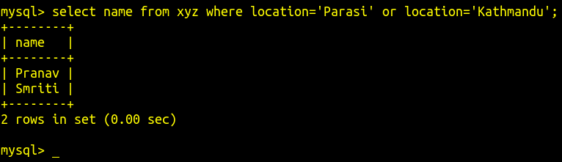
i. Write a SQL query to list the employees who are getting salary more than 25000 and less than 50000.
ii. Write a SQL query to list the employees who are belong the city of KTM or BRT.
iii. Write a SQL query to display the employee name who is getting highest salary to employee.
iv. Write a SQL query to display the total salary of each department.

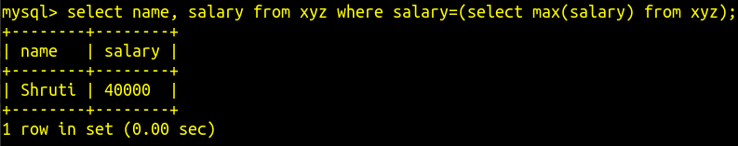
Ans:

i ans) select EmpName from EMPLOYEE where Salary between 25001 and 49999;

ii ans) select EmpName from EMPLOYEE where Empcity = KTM or Empcity = BRT;

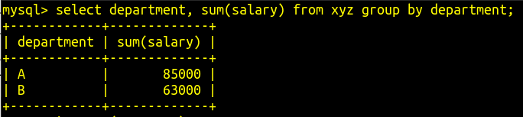
iii ans) select EmpName, Salary from EMPLOYEE where Salary = (select max(Salary) from EMPLOYEE);

iv ans) select Dept_no, sum(Salary) from EMPLOYEE group by Dept_no;
______________________________________________________________________________________________________________________________________________
3 b) What is normalization? Explain 3rd normalization with an example.
__________________________________________________________________________________________________________________________________________________
4 a) What is an encryption? How is an encryption protecting our data? Explain the type of encryption.
__________________________________________________________________________________________________________________________________________________
4 b) Define query and query optimization. Explain the steps for query processing.
__________________________________________________________________________________________________________________________________________________
5 a) What is indexing? Explain primary indexing with suitable example.
__________________________________________________________________________________________________________________________________________________
5 b) What are the basic causes of transaction failures? Explain the shadow page database recovery in details.

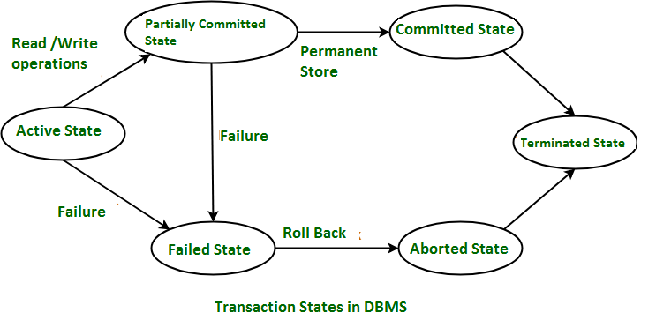
_______________________________________________________________________________________________________________________________________________
6 a) What is the major transaction state? Explain the Serializability in details.

A transaction in a database during its lifetime can be in one of the following states:

i) Active state
ii) Partially committed state
iii) Committed state
iv) Failed state
v) Aborted state
vi) Terminated state
These states govern the rules which decide the fate of the transaction whether it will commit or abort.

Serializability
When multiple transactions are running concurrently then there is a possibility that the database may be left in an inconsistent state. Serializability is a concept that helps us to check which schedules are serializable. A serializable schedule is the one that always leaves the database in consistent state.
Tips:
Sequence of operations is known as Schedule.
There are two types of Serializability.

i) Conflict Serializability
A schedule is called conflict serializable if we can convert it into a serial schedule after swapping its non-conflicting operations.

ii) View Serializability
View Serializability is a process to find out that a given schedule is view serializable or not. If a schedule is view equivalent to its serial schedule then the given schedule is said to be View Serializable.
__________________________________________________________________________________________________________________________________________________

6 b) What are advantages of fragmentation? Explain the type of fragmentation in details.

Fragmentation is a database server feature that allows us to control where data is stored at the table level.
Fragmentation enables u to define groups of rows or index keys within a table according to some algorithm or scheme.
Fragmentation should be done in a way so that the original table can be reconstructed from the fragments. This is needed so that the original table can be reconstructed from the fragments whenever required. This requirement is called “re-constructiveness”.

Advantages of fragmentation are:

- Since data is stored close to the site of usage, efficiency of the database system is increased.
- Local query optimization techniques are sufficient for most queries since data is locally available.
- Since irrelevant data is not available at the sites, security and privacy of the database system can be maintained.

There are three types of fragmentation which is enlisted below:
i) Vertical Fragmentation
In vertical fragmentation, the fields or columns of a table are grouped into fragments. In order to maintain re-constructiveness, each fragment should contain the primary key field(s) of the table. Vertical fragmentation can be used to enforce privacy of data.

ii) Horizontal Fragmentation
Horizontal fragmentation groups the tuples of a table in accordance to values of one or more fields. Horizontal fragmentation should also confirm to the rule of re-constructiveness. Each horizontal fragment must have all columns of the original base table.

iii) Hybrid Fragmentation
In hybrid fragmentation, a combination of horizontal and vertical fragmentation techniques are used. This is the most flexible fragmentation technique since it generates fragments with minimal extraneous information. However, reconstruction of the original table is often an expensive task.

__________________________________________________________________________________________________________________________________________________

7. Write shorts notes on any two:

a) BCNF

_______________________________________________________________________________________________________________________________________________
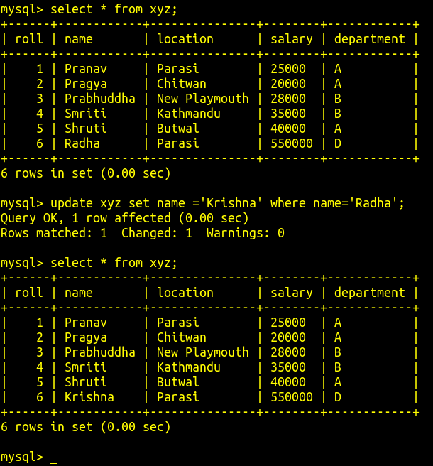
b) Update and Delete Statement

UPDATE statement
It is used to modify the existing records in a table.
For example:
update xyz set name="Krishna" where name="Radha";

In this example:
xyz is the table name.
name is the column name.

We have change Radha to Krishna using update statement.
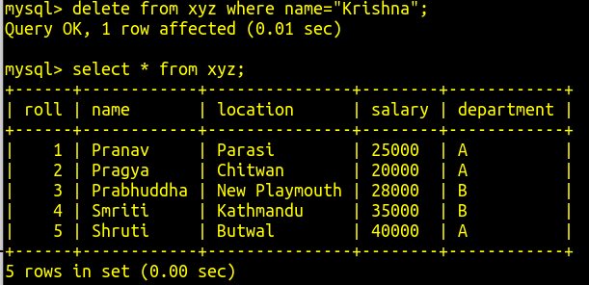
Deleting Statement
It is used to delete data from a table.

For example:
delete from xyz where name="Krishna";

Here we have deleted a row data using delete statement.
___________________________________________________________________________________________________________________________________________

c) Type of Joins
They are:
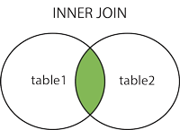
i) (Inner) Join
- Returns records that have matching values in both tables.

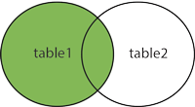
ii) Left (Outer) Join
- Return all records from the left table, and the matched records from the right table.

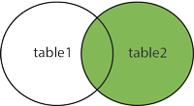
iii) Right (Outer) Join
- Return all records from the right table, and the matched records from the left table.

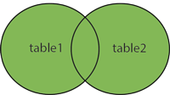
iv) Full (Outer) Join
- Return all records when there is a match in either left or right table.

__________________________________________________________________________________________________________________________

Extra Notes

Types of Database Architecture

i) Single Tier Architecture
In this architecture, the database is readily available on the client machine, any request made by client doesn’t require a network connection to perform the action on the database.

ii) Two Tier Architecture
In this architecture, the database system is present at the server machine and the DBMS application is present at the client machine, these two machines are connected with each other through a reliable network to access the database.

iii) Three Tier Architecture
In this architecture, the client application doesn’t communicate directly with the database systems present at the server machine, rather the client application communicates with server application and the server application internally communicates with the database system present at the server.
____________________________________________________________________________________________________________
In short:
A relational databases collection related of tables.
Each table consist of record.
A collection of table is schema.

The users of a DBMS can be broadly categorized as follows

i) Administrators
ii) Designers
iii) End users

Mapping cardinalities
i) One to one
ii) One to many
iii) many to one
iv) many to many

Two major types of Database
i) Relational database e.g. PostgreSQL, MySQL, MariaDB, etc.
ii) Non-relational database e.g. MongoDB, DynamoDB, Firebase, etc.

How to use database form terminal for practise? (mysql) Note:: commands are not case-sensitive.

sudo mysql //to login to mysql as root user.
select user,host from mysql.user; //to see all database users & their host
create user ‘username’@’localhost’ identified by ‘password’; //to create database user with password. Note: New user don’t have any privilege
grant all privileges on * . * to ‘username’@’localhost’; //to give all permission to database user. Note: In real life, don’t give all permission.
flush privileges; //to save permission changes.
drop user ‘username’@’localhost’; //to delete database user


mysql -u username -p //to login as a database user. We will need a password if where was one.
//u stands for username. p stands for password.

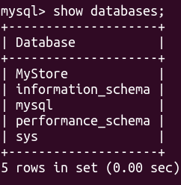
show databases //to see all database available

→ here except database named MyStore all other databases are default databases created by mysql.
→ MyStore is user defined database. We shouldn't use built-in database.
→ Use only user defined database or create one database using as mentioned below.

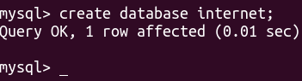
create database database_name; //to create a new database

→ internet is the database name.

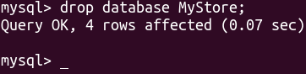
drop database database_name; //to delete a database. Here MyStore database is deleted.

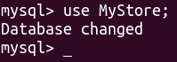
use database_name; //to select a database. We can’t create a table without selecting a database.

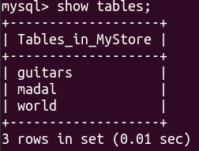
show tables; //to see all tables inside the database

→ here MyStore is the name of database we are using.
→ guitars, madal and world are the names of table inside that database.

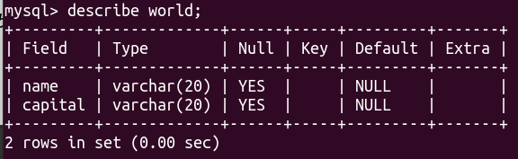

describe table_name; //to see a table outlook

→ here world is the table name.
→ name and capital are the column name.

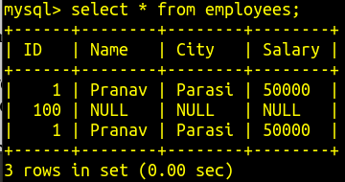
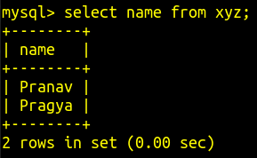
Here,
we are selecting particular column to display all of its contents.

xyz is name of table.
name is name of column.

select * from table_name; //to select all contents of the table

→ employees is the table name.

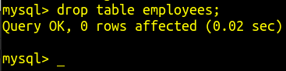
drop table table_name; //to delete a table

→ Here we deleted the table named employees.
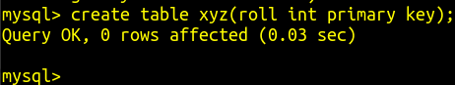
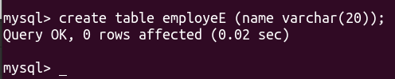
create table table_name (column_name column_property);

→ Here a table named employeE is created with a column named name.
→ We can't create a table without any column. At least 1 column is mandatory to create a table.
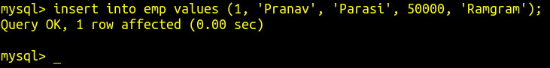
insert into table_name values (value1, value2, ...) //to insert data inside table

insert into table_name (column1, column2, ...) values ( data1, data2, …); //to insert data in particular column
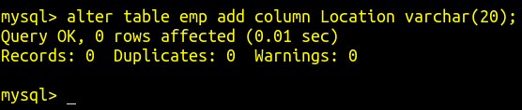
alter table table_name add column column_name column_properties //to add a column in table

→ Here we have added a column named Location inside a table named emp.
→ The Location column can with 20 string characters. VAR means variable.

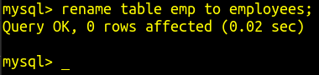
rename table old_Table_Name to new_Table_Name //to rename the table

→ Here emp is old table name which is renamed to employees.

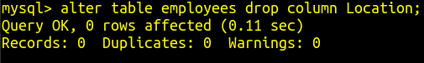
alter table table_name drop column_name; //to delete a column from table

→ Here we deleted column named Location from the table named employees.

alter table table_name modify column_name <datatype, table properties>; //to modify column properties
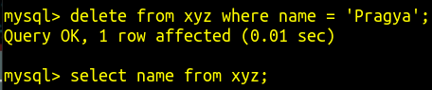
Delete a data from the table.

Here, Pragya is the data we deleted from the column name inside the table xyz.
_________________________________________________________________________________________________________________________________
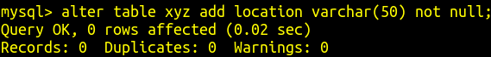
Types of Column Properties
Here, we added a new column.
location is name of column.
xyz is the name of table.
Not Null = We can’t leave the column empty. Example -
Unique = We can’t insert same data in that column.
Primary = A table have only one primary column which is unique & not null.
Default = A column whose value set to default will print default information if that column is left null.

________________________________________________________________________________________________________________________________

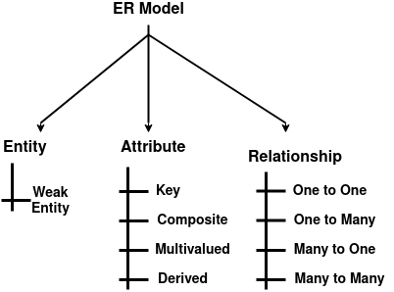
What are the components of ER diagram?
Note:
While making ER diagram:
i) Entities are denoted by Rectangle.
ii) Relationships are denoted by Diamond.
Iii) Attribute are denoted by Ovals.
i) Entity
ii) Attribute
iii) Relationship
Fig: Components of ER diagram ---------→

________________________________________________________________________________________________________________________________

Functional Dependency
An attribute Y is dependent on an attribute X if the value of X determines the value of Y, i.e., for each value of X, we obtain a unique value of Y.
Symbolically, it is represented as: X -> Y

If another attribute Z is also dependent on X, we can represent it as: X -> Y, Z

Trivial Dependency
⍺ → β is a trivial dependencies if β ⊆ ⍺ where, ⊆ denotes subset of.

Partial Dependency
Non-key attribute dependent on a part of the key attribute.

Transitive Dependency
Non-key attribute dependent on another non-key attribute.

